Algebra 1: Unit 14, Lesson H1

- Heidi is collecting data on whether or not her friends enjoy cooking. The results of her data are shown.
- $67\%$ of the people surveyed do not enjoy cooking.
- $62\%$ of the people surveyed were male.
- Of those surveyed who enjoy cooking, $61.5\%$ were female.
- $24.18\%$ of the males surveyed do not enjoy cooking.

What percent represents a conditional relative frequency?
$$61.15\%$$

- Demetrius surveyed the families in his neighborhood, asking them if they have any children and if they own any pets. The results of the data are summarized in the frequency table.
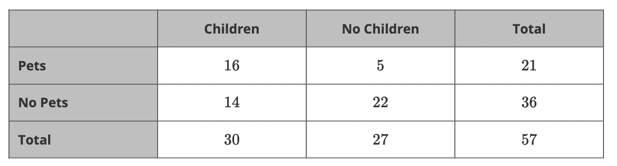
What is the joint relative frequency for families who do not own pets and have children?
$$24.56\%$$

- Oliver surveyed the families in his neighborhood, asking them if they have any children and if they own any pets. The results of the data are summarized in the frequency table.
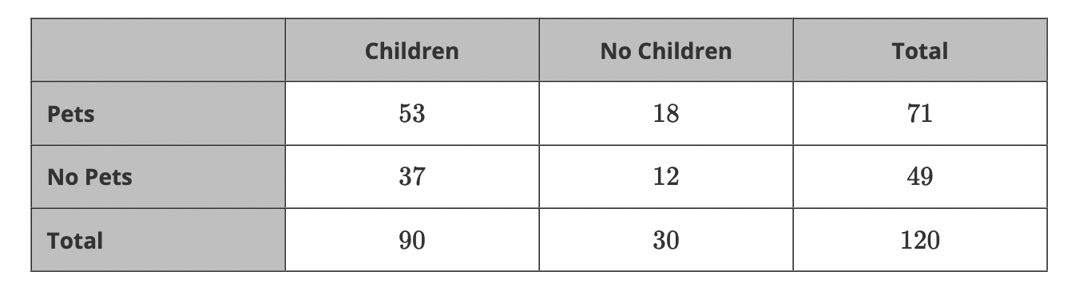
Oliver is using the data to create a relative frequency table.
What is the relative frequency of all children surveyed?
$$75\%$$

